**TITLE:** Data Collection for Hand Movements Using IMU and Bluetooth

**GOAL:**

* To estimate human hand movements and determine levels of activity in workstations.
* To learn how to capture data from accelerometer+gyroscope and use it for estimating orientation and movement of an object.
* To learn how to filter and display the collected data in a visual manner.
* To learn how to wirelessly communicate with a device using a Bluetooth module.
* To learn how to use battery and voltage regulator as power supply for portability.

**DELIVERABLES:**

* AVR C code
* Schematics
* PCB layout
* PowerPoint Presentation
* Any other documentation
* Visual presentation of captured data
* YouTube link: <https://www.youtube.com/watch?v=6fIou7R4bvI>

**LITERATURE SURVEY:**

Being able to capture data from hand movements and transmit them wirelessly could be useful for controlling other systems remotely. I am interested on expanding this project into a robotic arm that will imitate my own arm (or something similar). This project could also be useful for tracking a person’s typing patterns or estimating the level of activity in a workstation. It can possibly be used to find correlations between hand positions and carpal tunnel syndrome.

**COMPONENTS:**

* + AVR ATMEGA328P
  + Gyro/Accelerometer (MPU 6050)
  + Bluetooth module
  + LM7805 – 5V voltage regulator
  + 9V battery with connector
  + 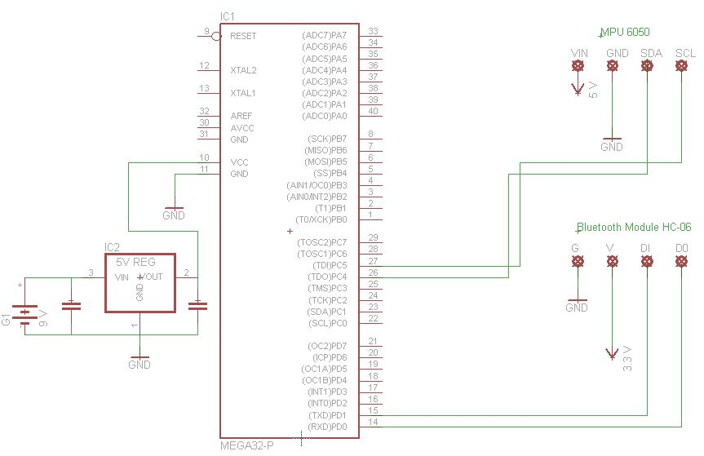“Bluetooth Terminal/Graphics” Android application

**SCHEMATICS:**

**PCB Layout:**

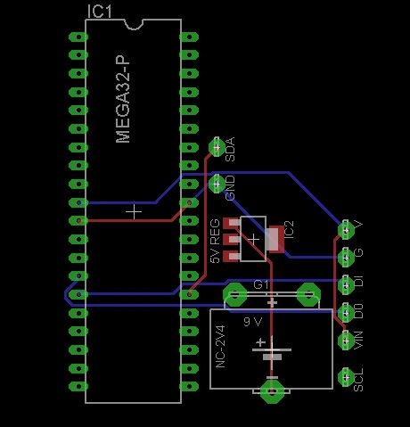

**IMPLEMENTATION PLAN:**

* + Learn to collect data from gyros/accelerometers.
  + Make sense of the data (e.g. turn into degrees).
  + Use ‘complementary filter’ to de-noise data.
  + Make the device wireless by adding Bluetooth capability.
  + Graph data on android device using “Bluetooth Terminal/Graphics” application.
  + Make the device mobile by using battery as power supply.

**SCREENSHOT OF CAPTURED DATA:**

